

LAB 2: Construction of an adaptive online grocery website

The purpose of this laboratory is to build a dynamic mini website that allows a user to purchase items at an online grocery store. Our focus will be on the functionality. During this

laboratory, you will need to:

* Get familiar with JavaScript for building dynamic web pages (responding to the user's actions).
* In conjunction with the theme of putting the user at the heart of the design process, your online grocery UI will have to be personalized in response to various characteristics of typical users.



SUBMISSION DEADLINE

* Sunday, January 26, 2024, 11:59 p.m.



SUBMISSION METHOD

* *WARNING: Any code or even "little piece of code" you take from such a stack overflow* or other website *should be accompanied by a* comment that *recognizes the source. You must, in your submission text, state "Code for X inspired by* *(link*

*html)")*

Submit a pdf document consisting of the following:

1. Group number
2. Group members
3. Each member contribution.
4. Link to the website.
5. Snapshots of the website created.



1. You need to familiarize yourself with JavaScript. Just like HTML/CSS, the [tutorial on the W3](https://www.w3schools.com/js/default.asp) [School w](https://www.w3schools.com/js/default.asp)ebsite is really great. Go step by step, but you won't be able to do everything, there are several items. Don't be discouraged as you will see that several elements of the tutorial areon basicstructures or operators containing any programming language (arithmetic operations, Boolean, functions, Random, String, objects, etc.). You've already this knowledge, it is only a different syntax.

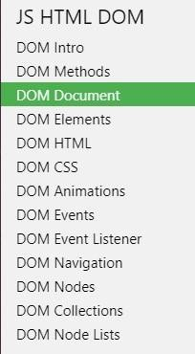

I urge you to quickly check out the section on HTML [DOM. T](https://www.w3schools.com/js/js_htmldom.asp)he dynamic aspect of websites comes from a small part of JavaScript, the one that allows you to find and modify HTMLs elements. Read this section on the JS HTML DOM, specifically the DOM Document sections (showing how to access an HTML item) and the DOM Events section showing how it is possible to listen (adding a

“listener") to the occurrence of events (mouse click for example) and react to it.

The [HOW TO section ](https://www.w3schools.com/howto/default.asp)

also contains

examples of navigation. The navigation code I provide you with this lab comes in part from this example on tab [titles](https://www.w3schools.com/howto/howto_js_tabs.asp) [.](https://www.w3schools.com/howto/howto_js_tabs.asp)

1. Your demonstration space will still be useful this week (and throughout the session). [Use](https://pages.github.com/) [GitHub Pages](https://pages.github.com/) which will allow you to have your own website at the address

username.github.io. I suggest you put your projects in separate directories, and thus have *username.github.io/SEG3525- LabX* as a directory for each lab.

Design

In connection with the task-based design model, I provide you with some information about your typical users. Here are two characters and their goals.

Eric,45, has a gluten intolerance. He would like to do his groceries without being offered items containing wheat. He prefers to buy organic products, unless it is very expensive. Eric feels intimidated by all the vegetable names he doesn't know and prefers to see pictures.

Lucie, 28, is a vegetarian. She would like to be able to do her groceries without being offered meats and fish. It has a limited budget, so likes to see the items in order of price to be able to buy the cheapest. Lucie has vision problems too, so she appreciates when the characters on the screen are big enough.

In a real design situation, you could now think of a to-do list for each purpose and that list would lead you to design requirements. But... As we are in the end of university courses, I will give you programming requirements to consider these characters, but also get you to learn elements of JavaScript.



STARTING POINT

To help you (for those who need it) I provide you with some code. The [directory SEG3125- Module1-](https://github.com/carolinebarriere/carolinebarriere.github.io/tree/master/SEG3125-Module2-Grocery) [Grocery](https://github.com/carolinebarriere/carolinebarriere.github.io/tree/master/SEG3125-Module2-Grocery) contains the source code and you can see the rendering of the site [here.](https://carolinebarriere.github.io/SEG3125-Module2-Grocery/)

This is a small 3-page site that you will need to edit. A navigation bar (Client, Products, Cart) allows you to move from one page to another. Look in the hand file.js for the JavaScript of this navigation.

* 1. The Customer page allows the user to select whether he is vegetarian or allergic to gluten.

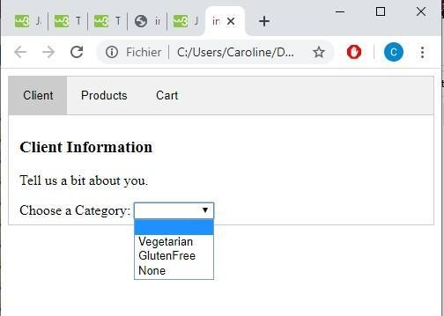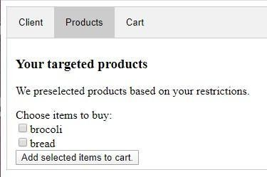

* 1. The products page shows a subset of products based on user dietary restrictions.
  2. 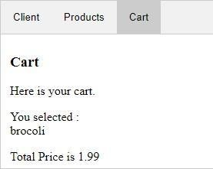The Cart page shows what is in the cart and the total.

Suppose 3 grocery items: broccoli, wheat bread, salmon, an "adaptive" grocery store that meets Lucie and Eric's needs should limit Lucie's selection to bread and broccoli, and selection for Eric with broccoli and salmon. This would increase their productivity by not having to browse items they won't want to buy anyway.

As you can see, so far, the site is very basic! It will be up to you to change the code and incorporate elements that will meet the goals of Lucie and Eric.



Programming

Using HTML/CSS/JavaScript, you need to generate a small, dynamic website that allows a user to shop online.

Basic requirements of your page (Compulsory)

Our focus for this week will be to have a site with correct functionalities. Since, many of you are beginners in JavaScript, that will be enough.

Your website should contain:

* The name of the grocery store *(this is not present in the code provided)*
* At least 10 possible products in the product list*.*
* Navigation between two or three zones depending on your information pooling.
* A personal data entry area o Each user may be vegetarian and/or allergic to gluten.

*(The code provided does not considers the OR... change it).*

* + Each user can indicate a preference for organic or non-organic products. *(This is not considered in the code provided, it needs to be added in the Options section, and add it as a variable in the list of products).*
* An area for the choice of items o Items should be priced. *(to* add *to the code provided)* o Items should be in sorted by price. *(to* add *to the code provided)*
* An area to view the cart.
  + The contents of the cart and its total.
* Your signature *(Website designed by ...)* at the bottom of the page.
* The use of external CSS (separate file) to set styles for titles, divisions, your signature at the bottom of the site. Explore font changes, colors, alignment, etc., to make the site a little prettier. For this lab, your rating will be on the feature, so don't waste too much time here if you're just starting out.
* Using JavaScript (separate files) to contain the script associated with the site.

Additional possibilities (Optional)

* Add user characteristics (e.g., diabetic, lactose intolerant) • Use photos to show which items to choose from
* Change the size of the characters for Lucie.
* Allow the addition of quantities.
* Add any other HTML/CSS elements to improve site rendering.



EVALUATION

* This lab is worth 3%.



Questions

* You can also send your questions directly to TA’s email